**Module 3 Lab 2: Integrating MongoDB with Express.js**

Naga Sumanth Vema

IFT 554: Middleware Programming & Database Security

Dinesh Sthapit

February 18th, 2024

**Module 3 Lab 2: Integrating MongoDB with Express.js**

Screenshot 1: Of the Express.js server code in app.js and the browser displaying "Hello World!".

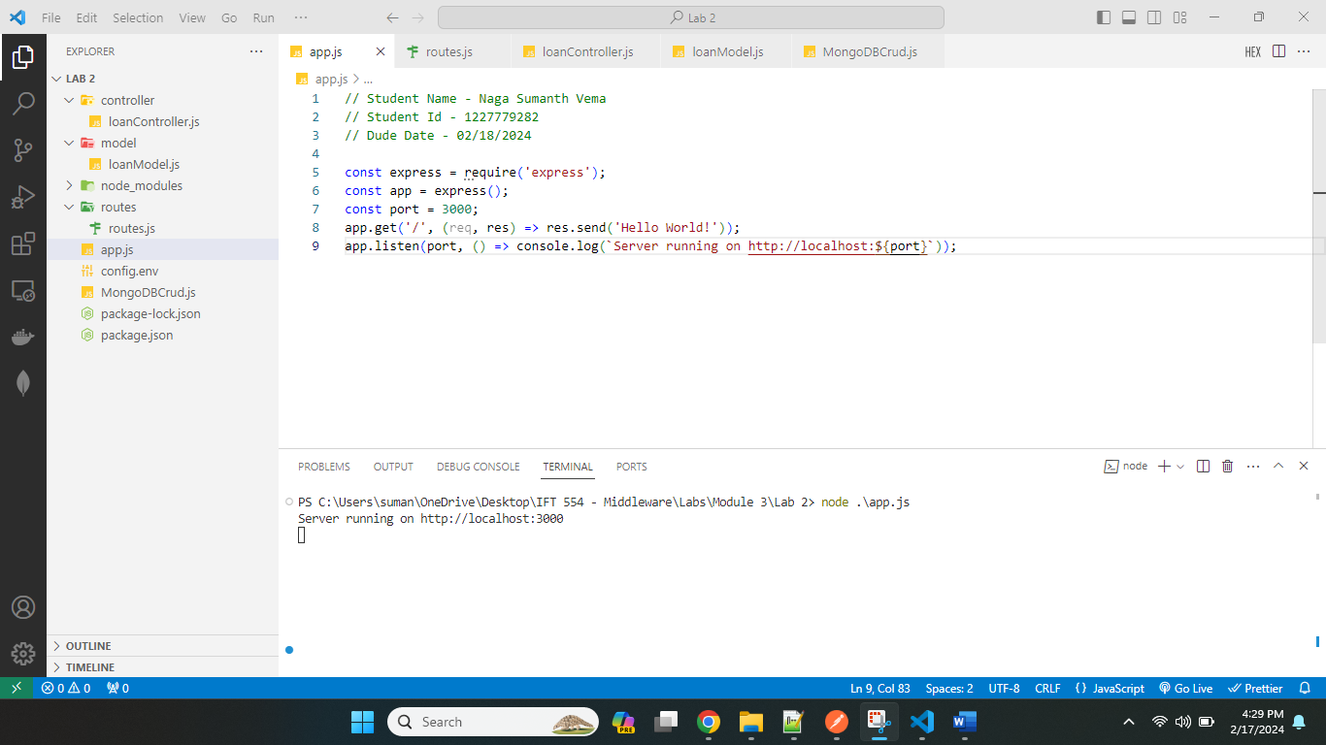

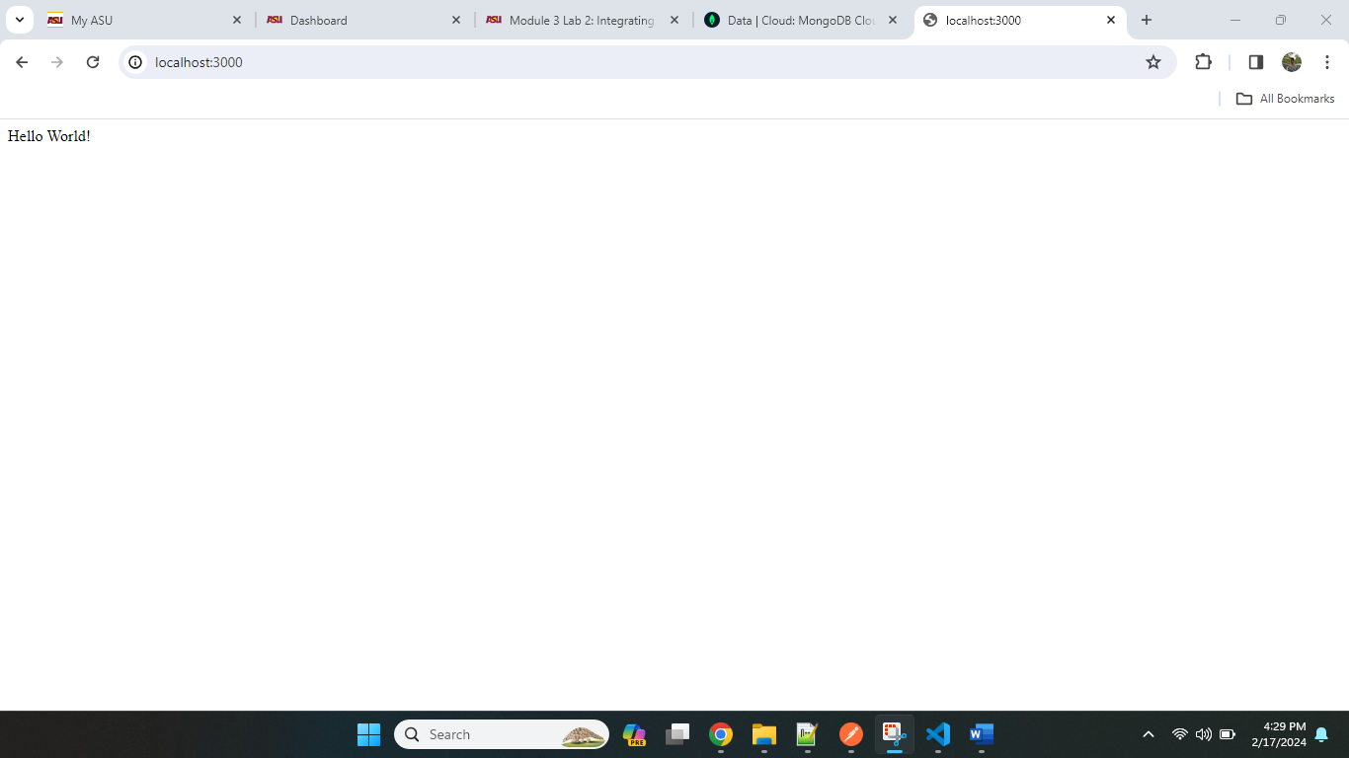

Screenshot 2: Of your routing code in Express.js, showing the CRUD operation routes.

Router.js

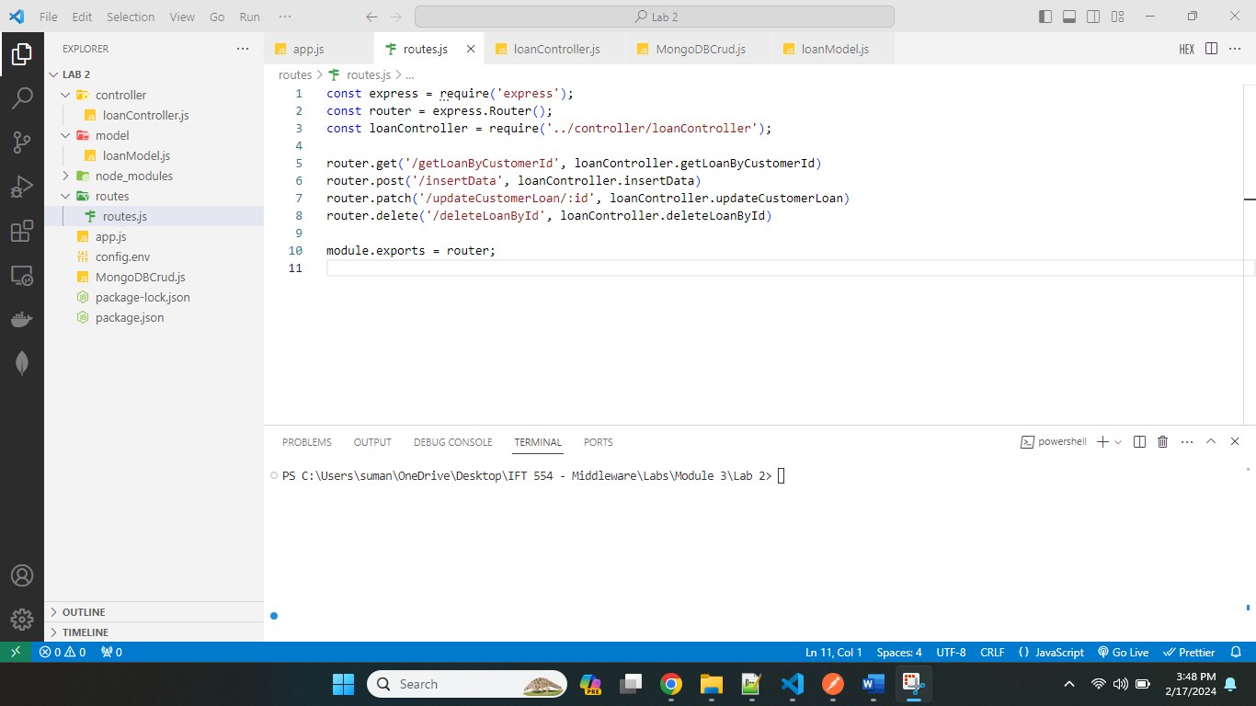

Controller.js

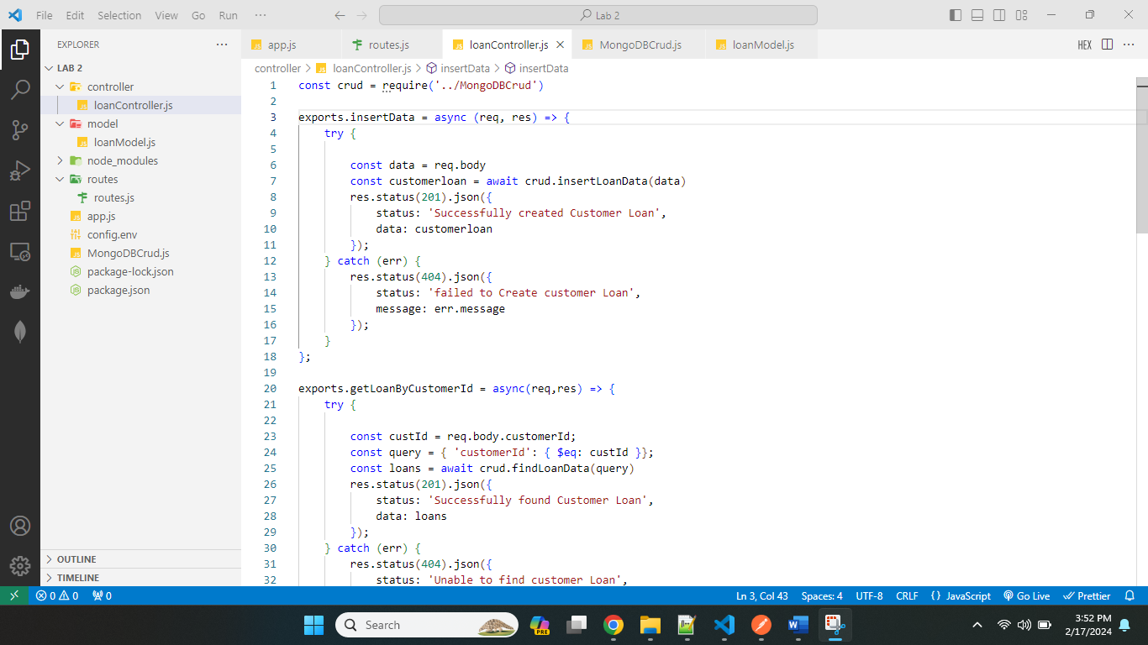

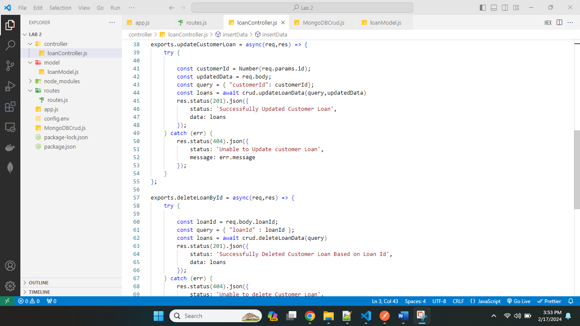

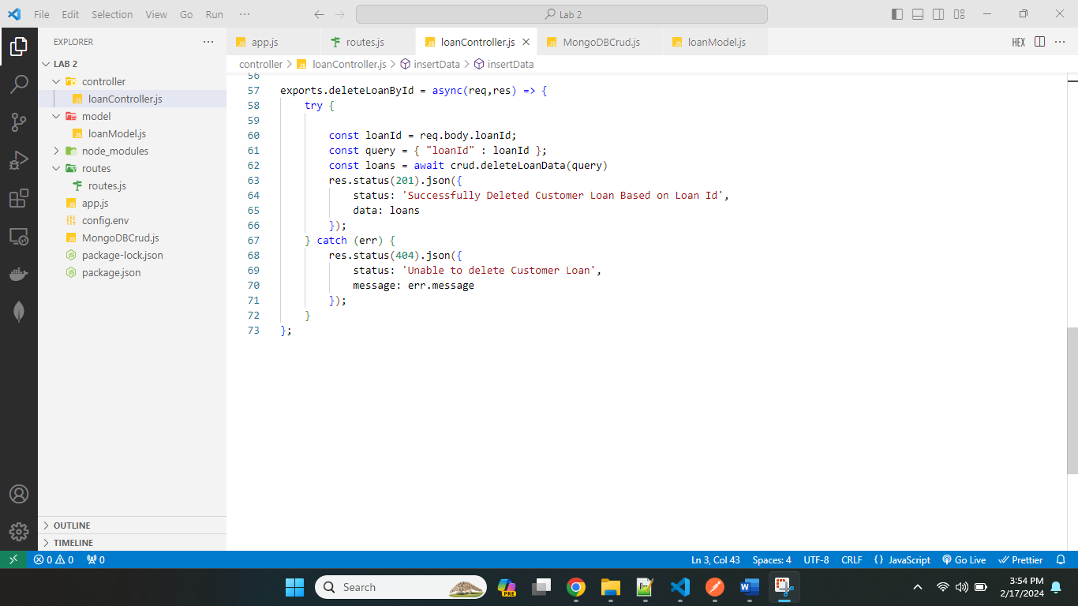

App.js

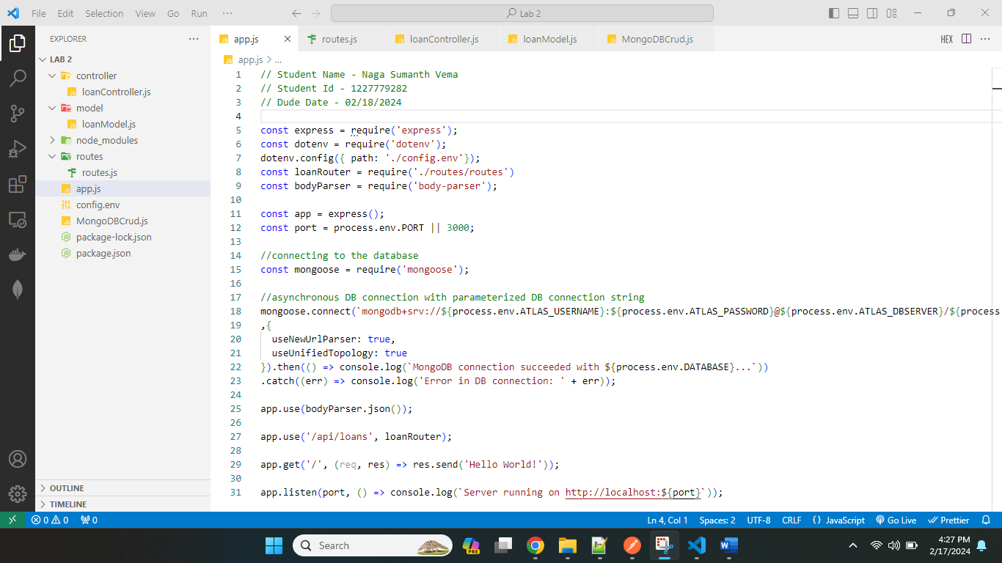

Screenshots of Postman (or similar tool) showing successful API requests and responses, and any debugging process in VSCode.

Insert Operation Screenshots:

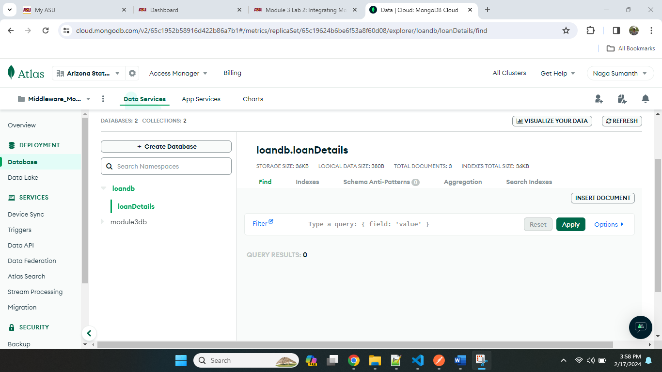

Above screenshot shows empty or zero records in the database in mongo atlas.

Postman API call screenshot:

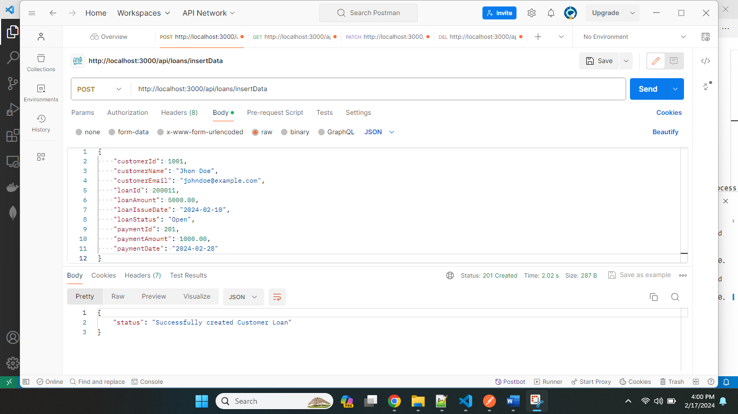

Terminal Screenshot:

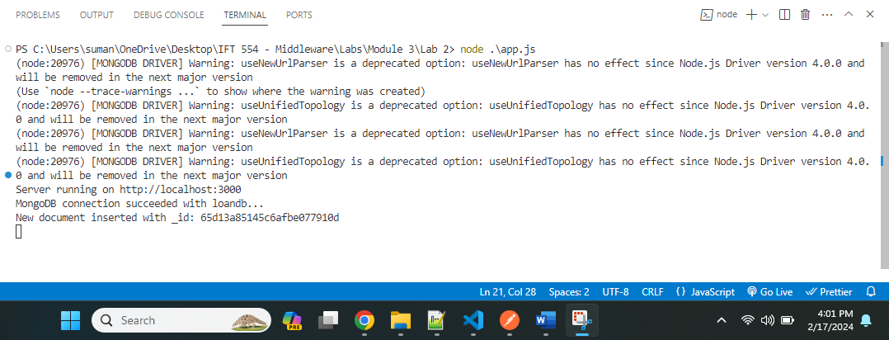

Atlas Screenshot

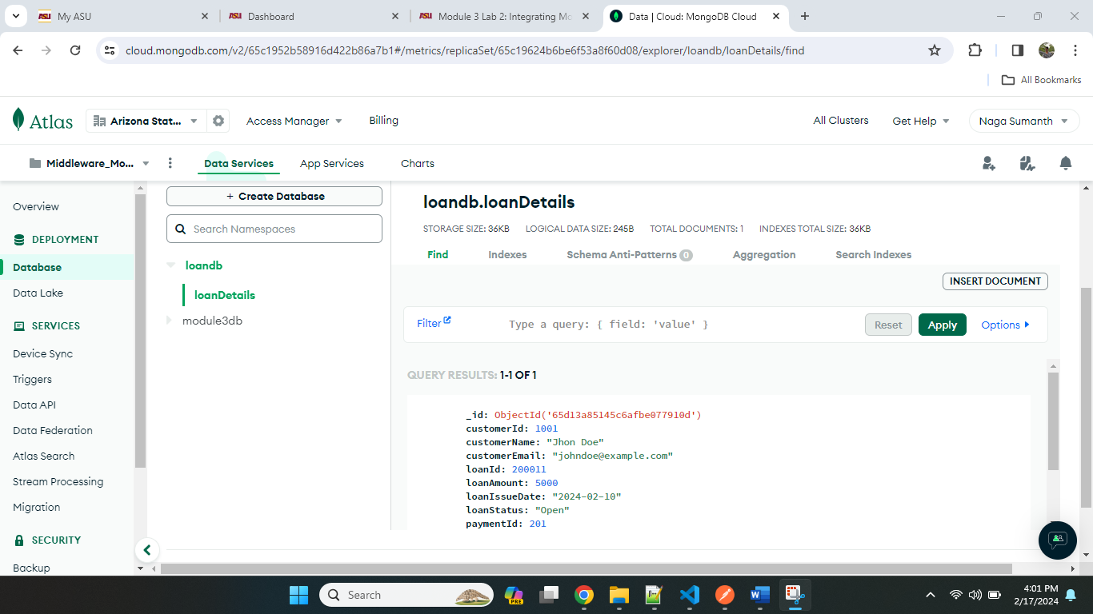

Find Operation: Searching the customer based on customerId : 1001

Postman Screenshot:

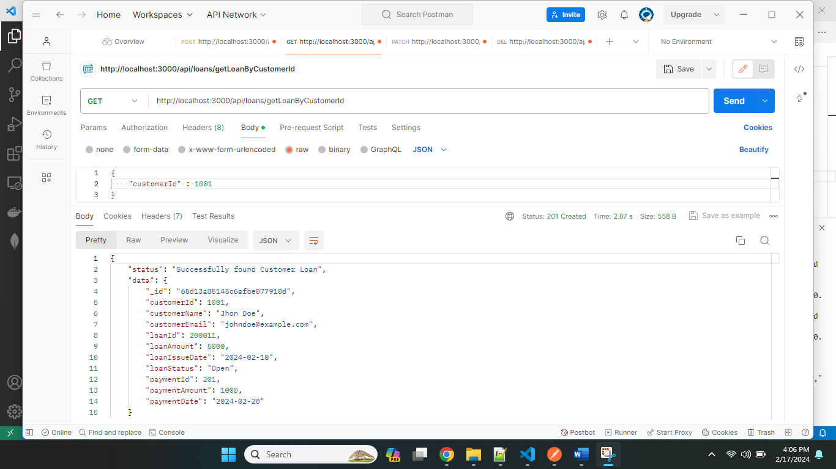

Terminal Screenshot:

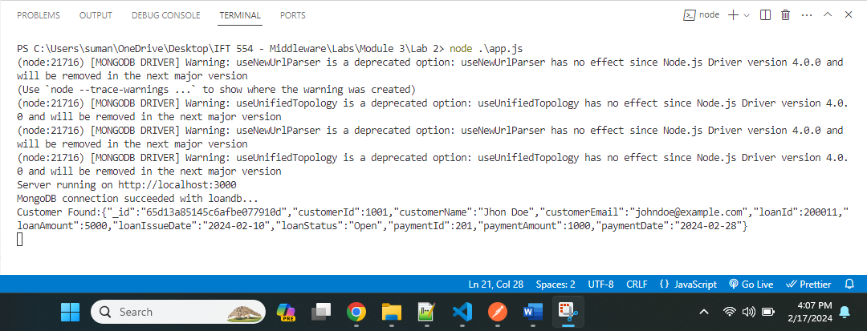

Atlas Screenshot:

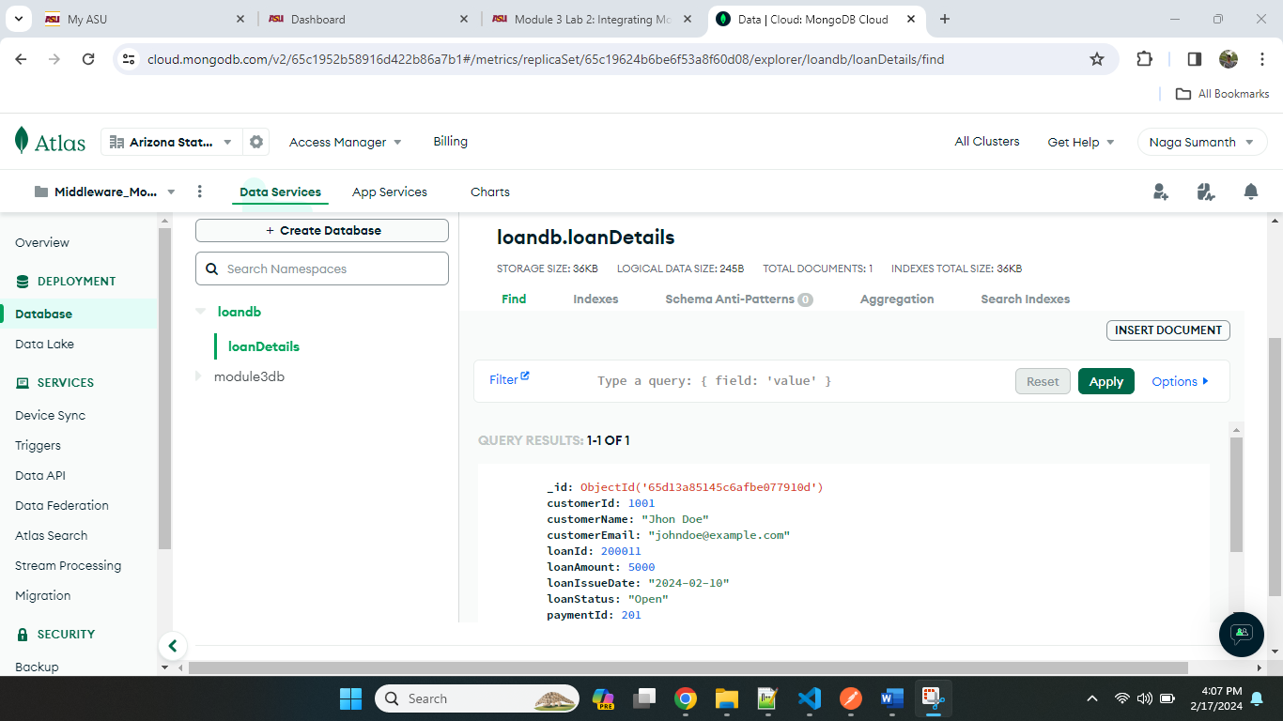

Update Operation: Updating the customer of Id 1001 by changing customerName to Sumanth.

Postman Screenshot:

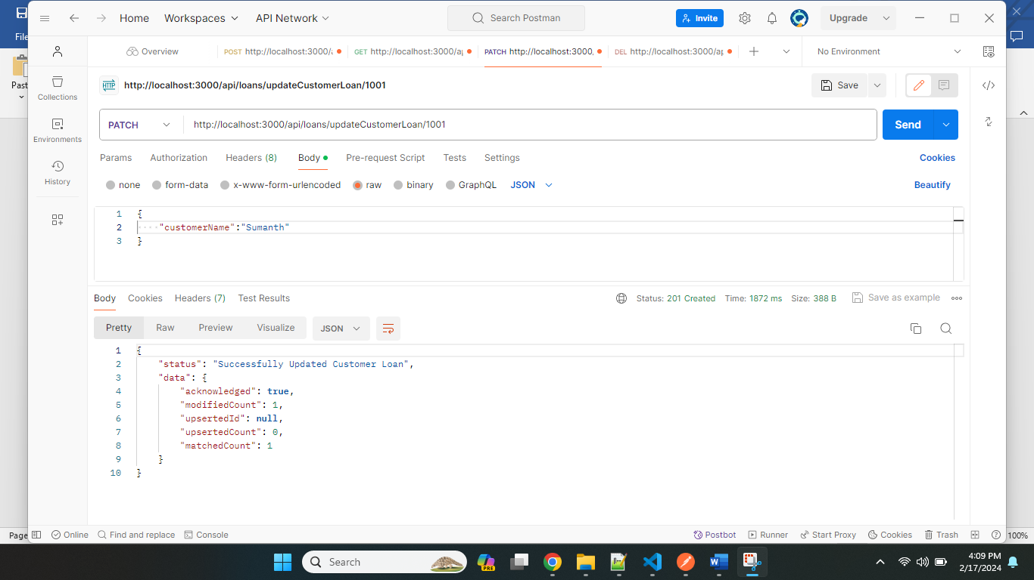

Terminal Screenshot:

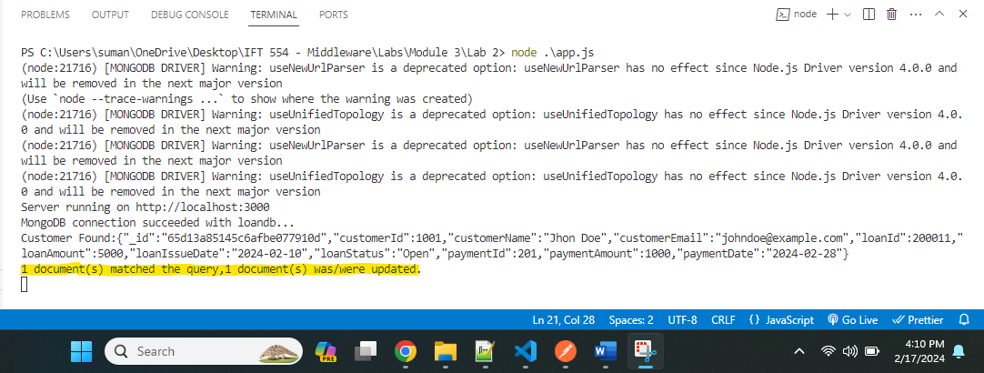

Atlas Screenshot:

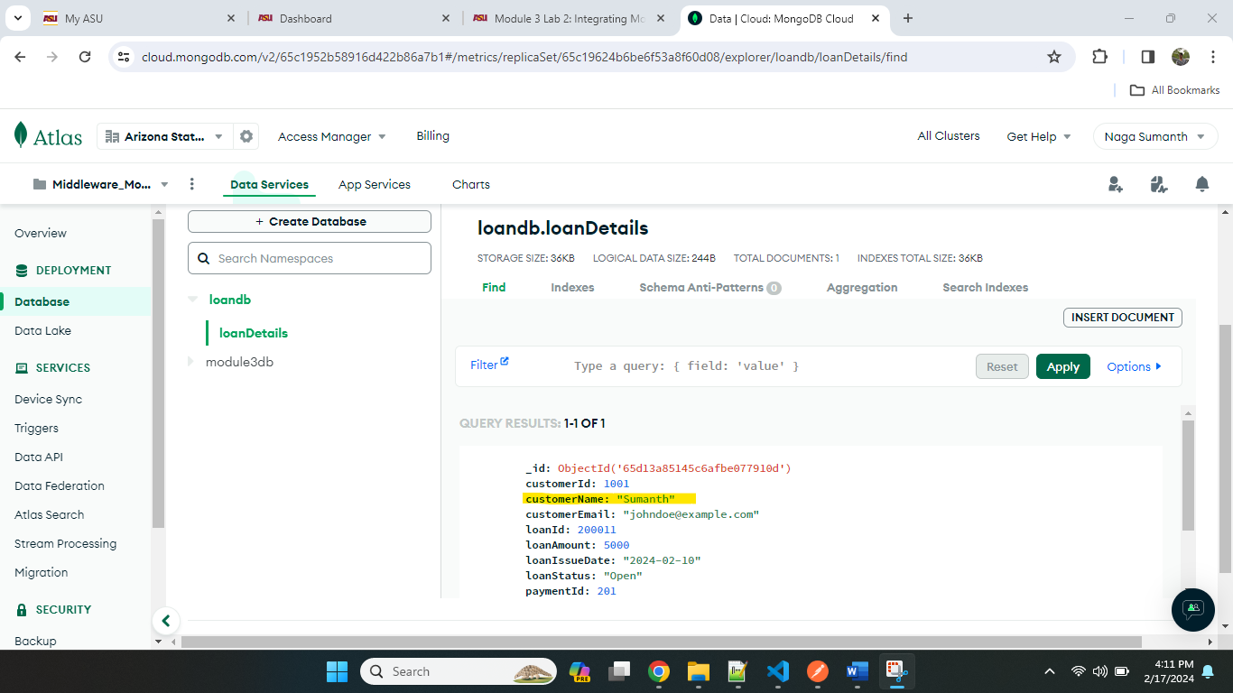

Delete Operation: Deleting the customer base on Id.

For this operation, I’m inserting a new document.

I have added new customer with Id 1002, Below screenshot shows successful insertion of record.

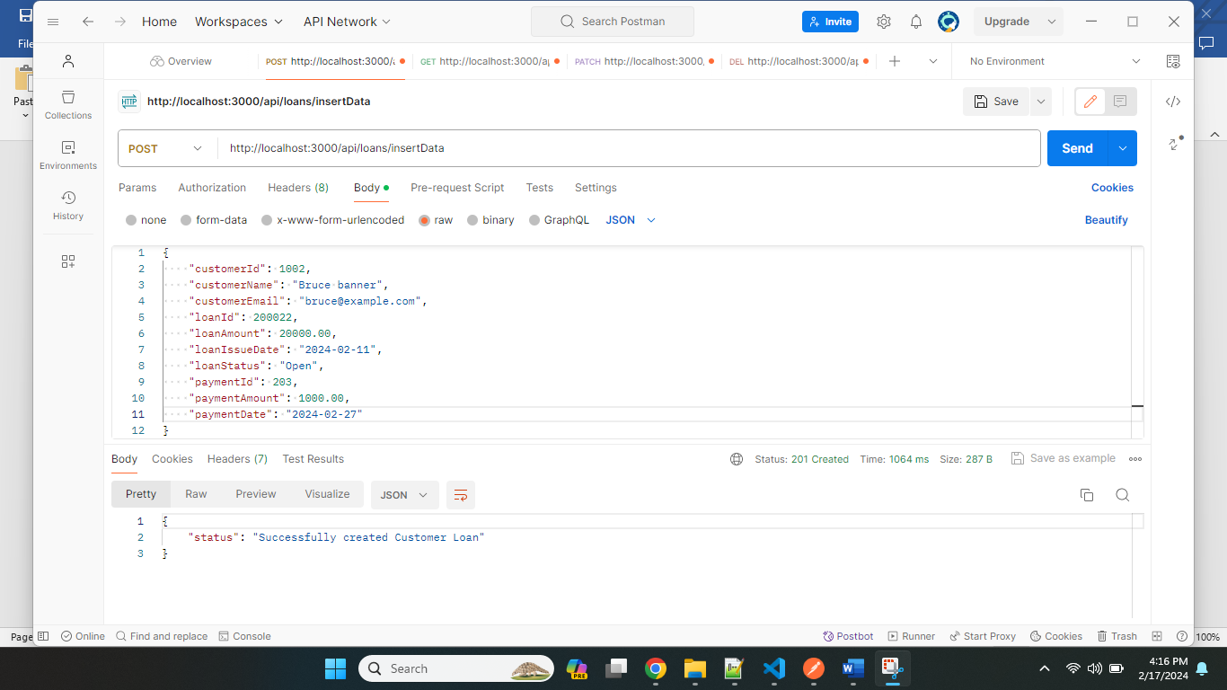

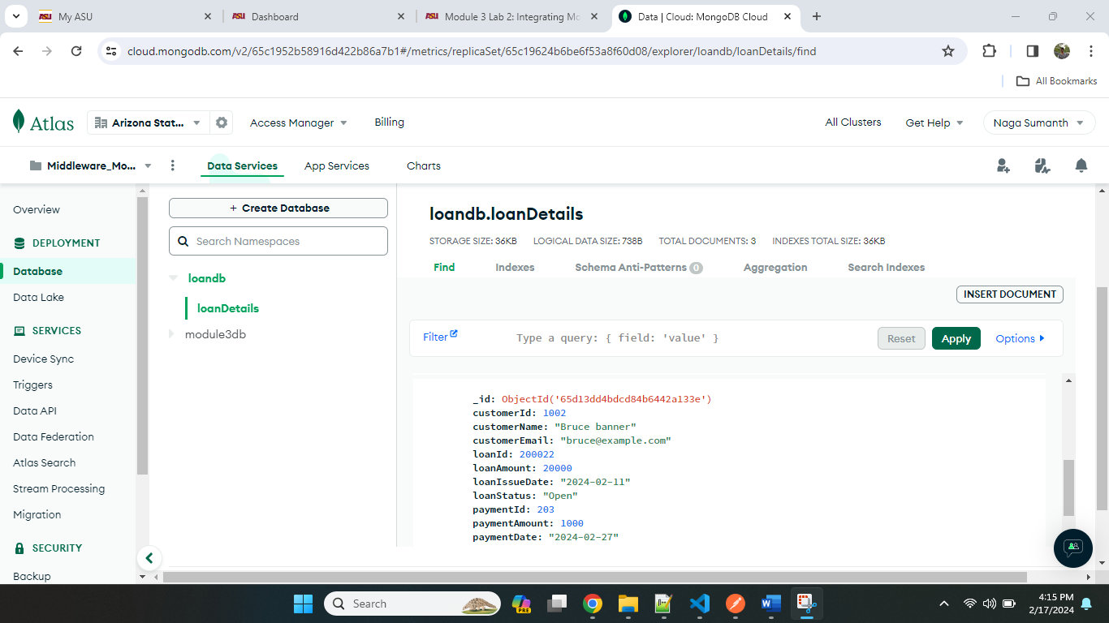

Now I will delete this customer 1002 using delete operation with help of Loan Id column (200022).

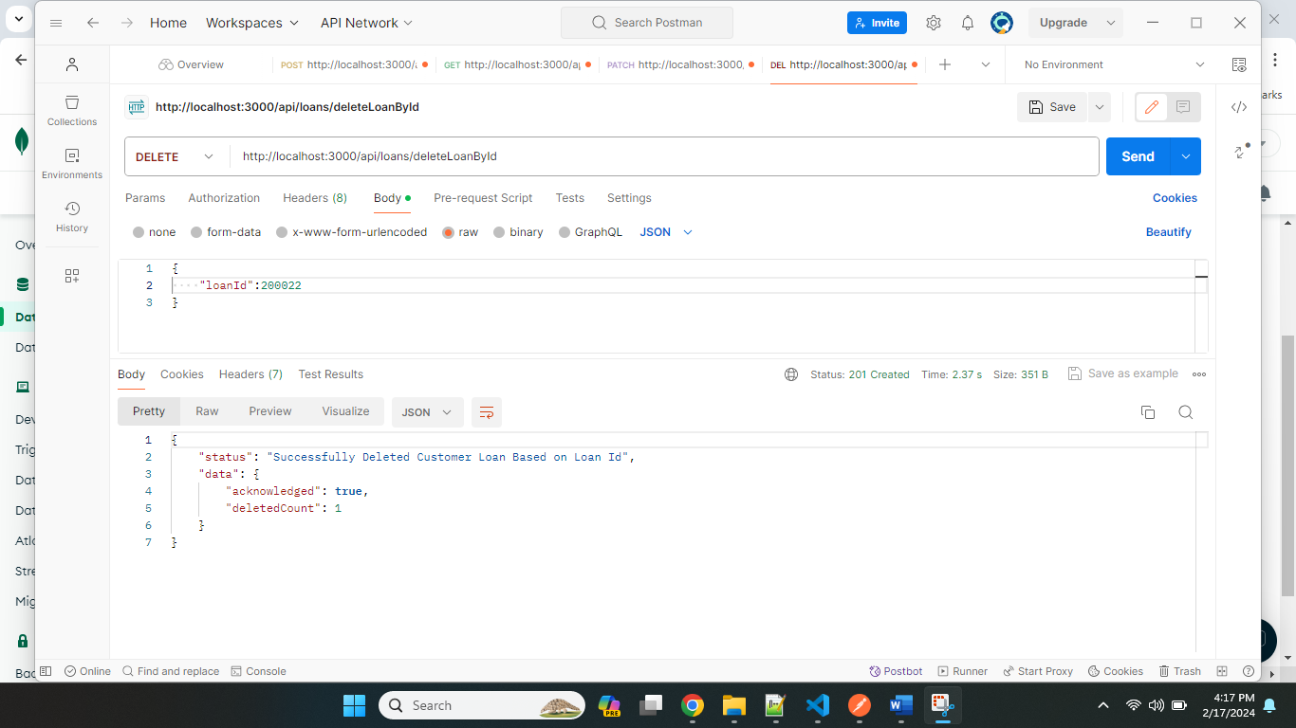

Terminal Screenshot:

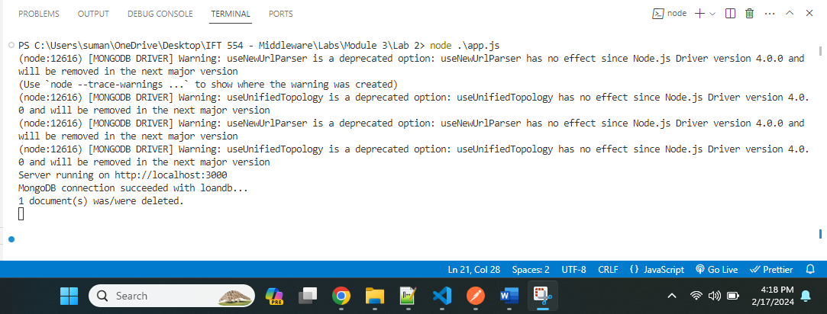

Atlas Screenshot:

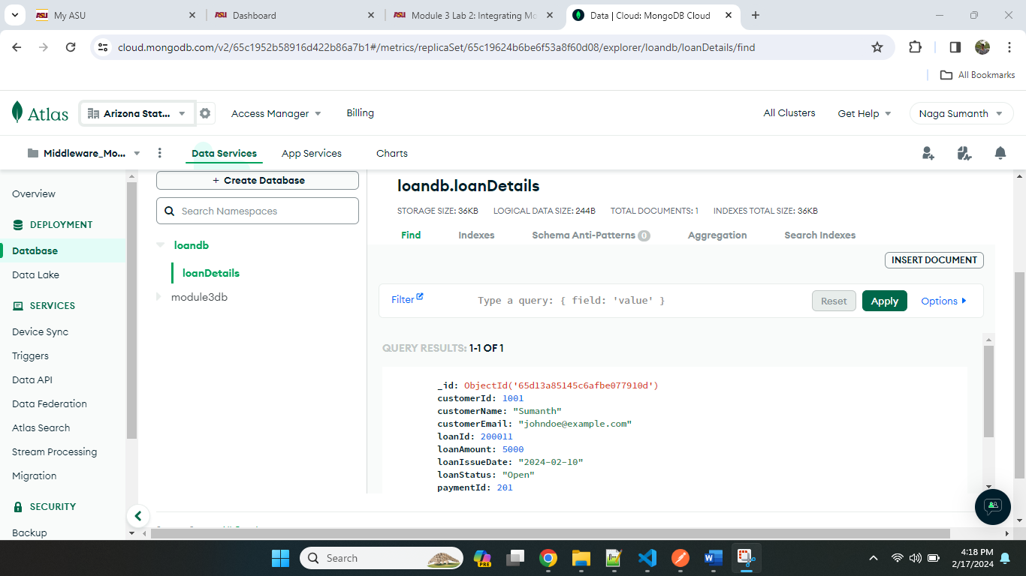

The above atlas screenshot shows 1 record because we have deleted the other record.